Blender Batching
Version 0.1.1
under GPL V3
by Alexander Hawliczek
08.2014



Table of Contents
Use 2
Functions 2
Buttons 2
List 2
Option 2
Batch files 3
Render files 3
Other 3
List 3
Use 3
Name 3
Folder 3
Start 3
End 3
Threads 3
FileMask 3
Output 3
Working the list 3
Context menu 4
Limits 4

Use
Ever had to update multiple assets in different blend files. You used the great blender linking system and change one linked item. Or you just want to browse your blends to quickly render some frames.
In any way you face a lot of boring searching, adjusting some settings and rendering one blend after another...
Now smile up. Start your "Blender Batching" let it search your blends, choose some and render the frames you want to where you want. Instantly or save the list as batch file for later.
All by using this little blender command line frontend.

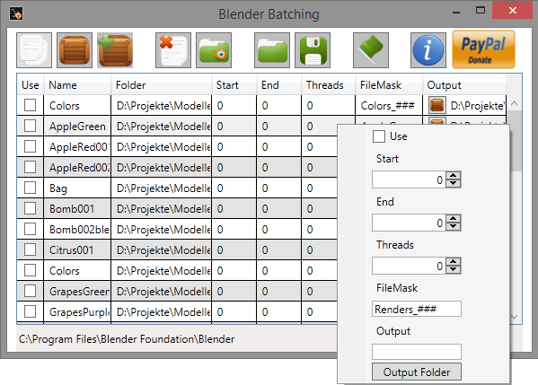
Functions

Buttons

List
- Add single / multiple files
- Add folder
- Include subfolder switch
- Clear list

Option
- Set blender path

Batch files
- Load list from batch file
- Save "Use" selected blends as batch file

Render files
- Start / stop "Use" selected blends rendering as background thread

Other
- Info
- Donate if you want / can with PayPal

List

Use
Check to use this blend file for batching / rendering.

Name
Name of the blend file.

Folder
Folder of the blend file.

Start
Start frame for batching / rendering. Set to "-1" to use blend file values.

End
End frame for batching / rendering. If this value is smaller or equal the start value a single frame will be rendered.

Threads
Number of threads to be used for rendering "0" for automatic and "-1" for blend file value.

FileMask
Mask for the file names of the rendered images. "###" stands for the frame number.

Output
Output folder for the blend file.

Working the list
Simple double click allows you to change the cell value. (Common table editing)
"Output" has a button for a folder select dialog, but can be edited directly, too.
"Name" and "Folder" are not editable.
The <delete> key removes selected line(s).
You can sort the list by clicking on the headers.

Context menu
You can select multiple blends and change all of them to the values you enter into the context menu. Changes happen as soon as you change one value and only for that property.

Limits
No render formats selectable so far (blend file value is used).
Background rendering renders frame by frame for better response on cancel requests.
Windows with .Net 4.5 only so far.

Disclaimer
Do what you want, but do it on your own risk.

Please feel free to leave critics and comments at Blender Batching @ GitHub

Have fun & and be well.
AH

